Lab Exercise 18- Scanning IaC Templates for Vulnerabilities
Objective
- Learn how to scan Infrastructure as Code (IaC) templates for security vulnerabilities.
- Use open-source IaC security tools to detect misconfigurations.
- Understand common risks such as public access, unencrypted resources, and insecure network rules.

Prerequisites
- A Linux/Windows/Mac machine with:
  - Terraform installed (for sample IaC)
  - Checkov (pip install checkov) or tfsec (brew install tfsec or binary download)
- Git installed (optional, for version control of IaC templates)

Step 1: Create an Insecure IaC Template
Create a file named main.tf with the following Terraform code:
provider "aws" {
region = "us-east-1"
}
resource "aws_s3_bucket" "insecure_bucket" {
bucket = "my-insecure-bucket-lab"
acl = "public-read"
}
resource "aws_security_group" "insecure_sg" {
name = "insecure-sg"
description = "Allow all inbound traffic"
ingress {
from_port = 0
to_port = 65535
protocol = "tcp"
cidr_blocks = ["0.0.0.0/0"]
}
}

Step 2: Scan the Template with Checkov
Run Checkov on the current directory:
checkov -d .
Expected Findings:
- Public S3 bucket access (public-read)
- Security group open to all inbound traffic

Expected Findings:
- Warns about S3 bucket without encryption
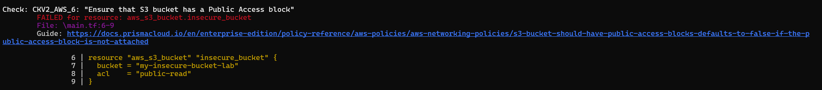
- Flags open Security Group rules

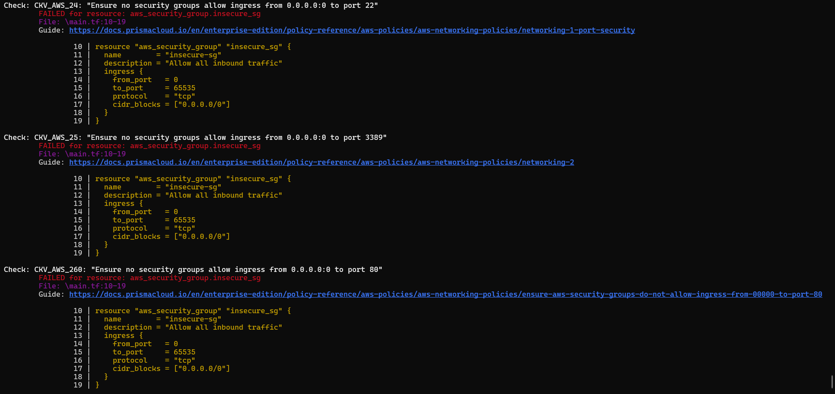

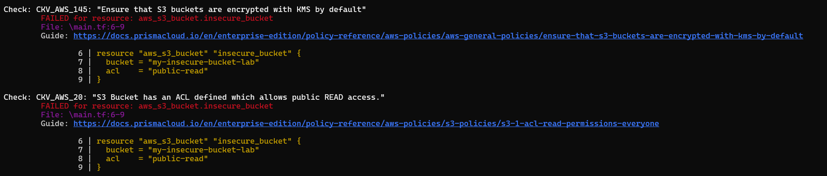

Step 4: Review the Report
Example output (Checkov):
Check: CKV_AWS_20: "S3 Bucket allows public read access"
FAILED for resource: aws_s3_bucket.insecure_bucket
Check: CKV_AWS_260: "Security group allows ingress from 0.0.0.0/0"
FAILED for resource: aws_security_group.insecure_sg

Step 5: Apply Fixes (Optional)
Modify the IaC template to:
- Set S3 bucket ACL to private
- Enable encryption (AES256)
- Restrict Security Group to specific IP ranges

Step 6: Rescan the Template
Run the scan again:
checkov -d .
Now the findings should be resolved or reduced.
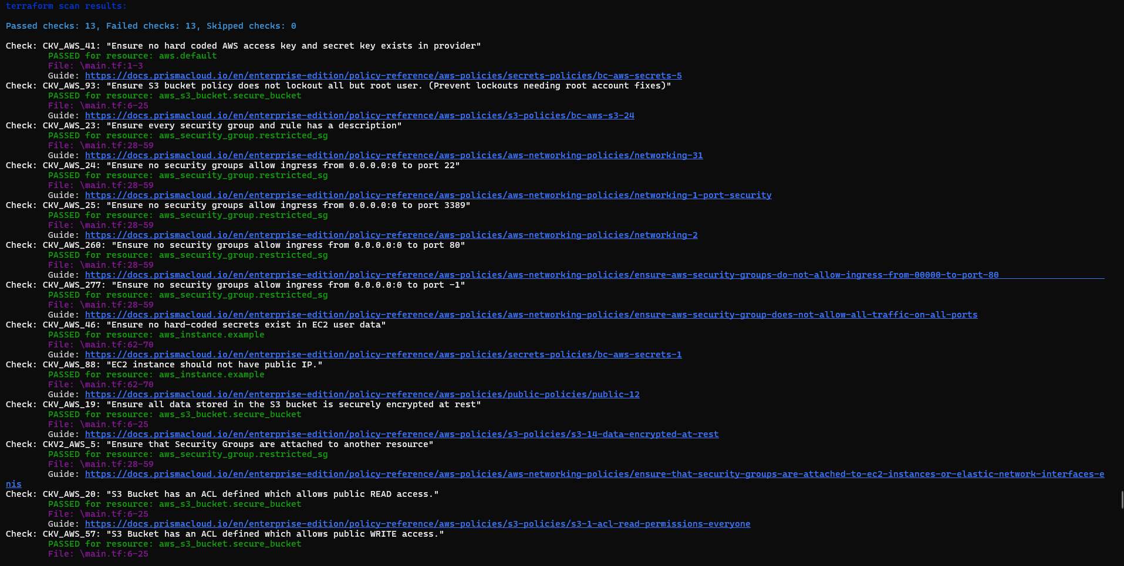

Step 7: Document Findings
Create a simple findings log:

